FELL DETECTION

CS328 – Group 7 Final Project

Weihai Chen, Xinyong Qiu, Che-Wei Lin

What the app is supposed to do…

The app detects falling from the users and follow up with responses: Immediately open a new popup window and the user have 15 seconds to press the “I’m fine” button or “I need help!” button. At this point, the phone will vibrate and play the ringtone (depend on user’s preference) to get attention for help in case of a serious fall. After 15 seconds or user has pressed “I need help!” button, the phone will call the designated phone number inputted by the user.

Data Collection

Activities involved in collection: walking, jogging, jumping, stationary, falling, sitting down, dropping phone, squatting

Each activity was collected for 5 minutes instead of **falling, sitting down and dropping phone**. For those 3 activities, we did not actually use a timer. Instead, we look at the previous data collection and discover that each activity have collected about 15,000 accelerometer reading over 5 minutes. We then followed the procedure like so: Start collecting labeled data, begin, stop collecting, get up, and start collecting again until we have 15,000ish data. For falling, we putted our bed on the ground and fall on the bed. Two persons perform falling and each fall takes about 5 seconds and we have perform about 60 falls in total.

Data Accuracy

We have implemented as many feature as possible. We have trained decision tree classifier with 8 different parameter, support vector machine, random forest and logistic regression over 10-fold cross validation. Most of the classifier weren’t having a good result as compare to Random Forest Classifier with ~92% accuracy most of the time.

Here are the statics:

The average accuracy is 0.927841979651

The average precision is [ 0.93218008 0.91211511 0.93003415 0.97840179 0.87025369 0.93067316

0.92581024 0.9437186 ]

The average recall is [ 0.97939478 0.94510706 0.94052475 0.98107169 0.84794411 0.82523635

0.90351105 0.99154708]

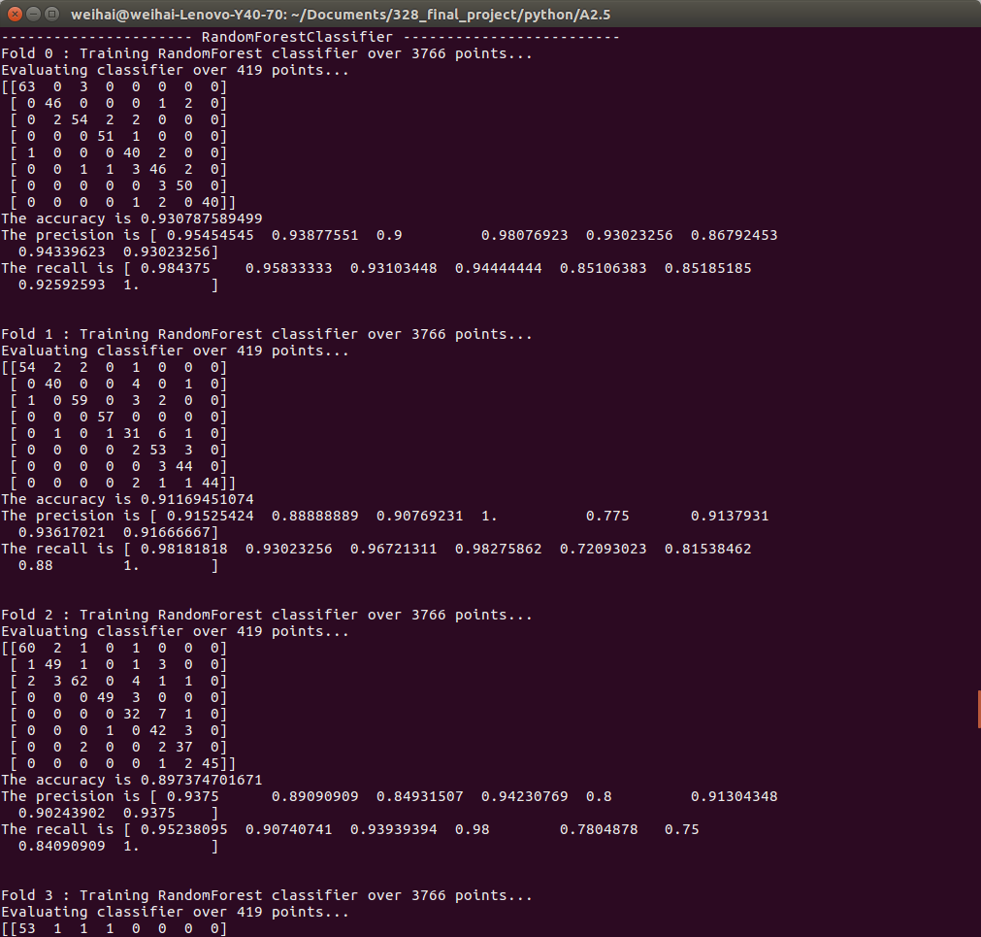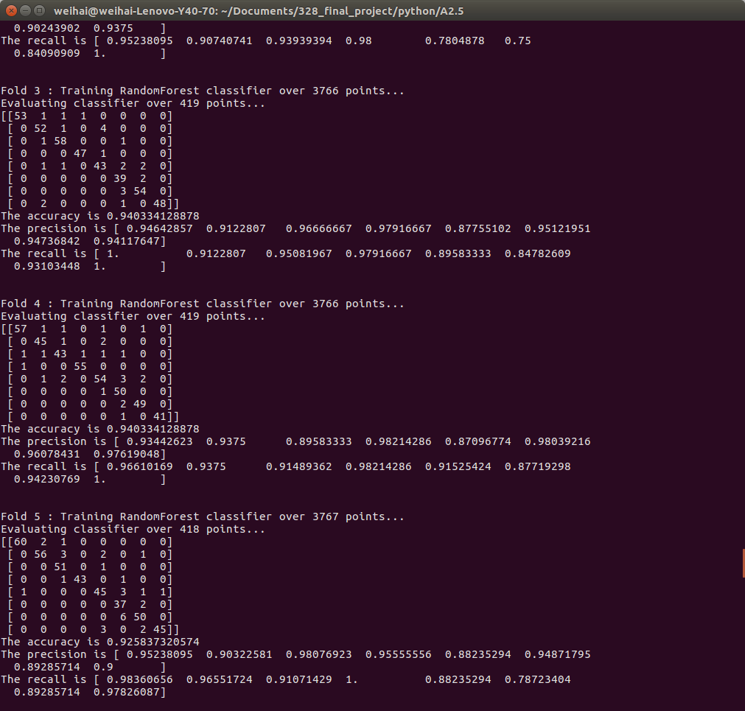

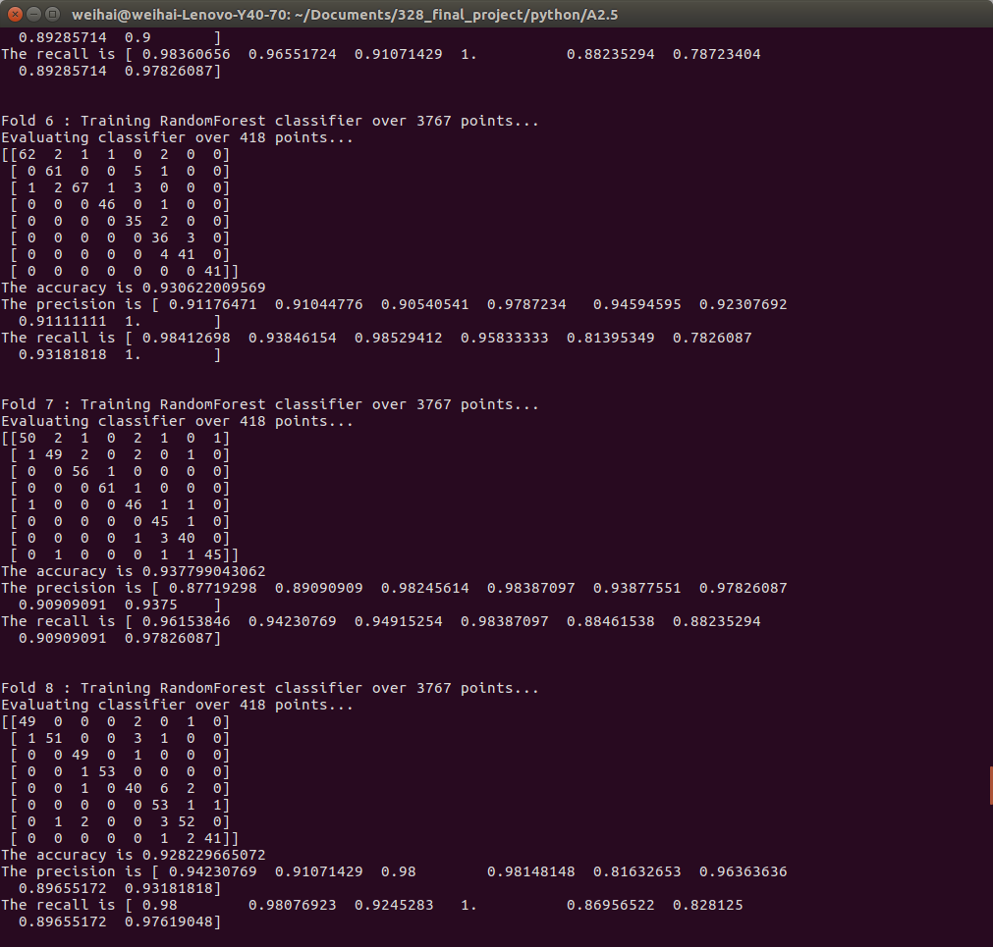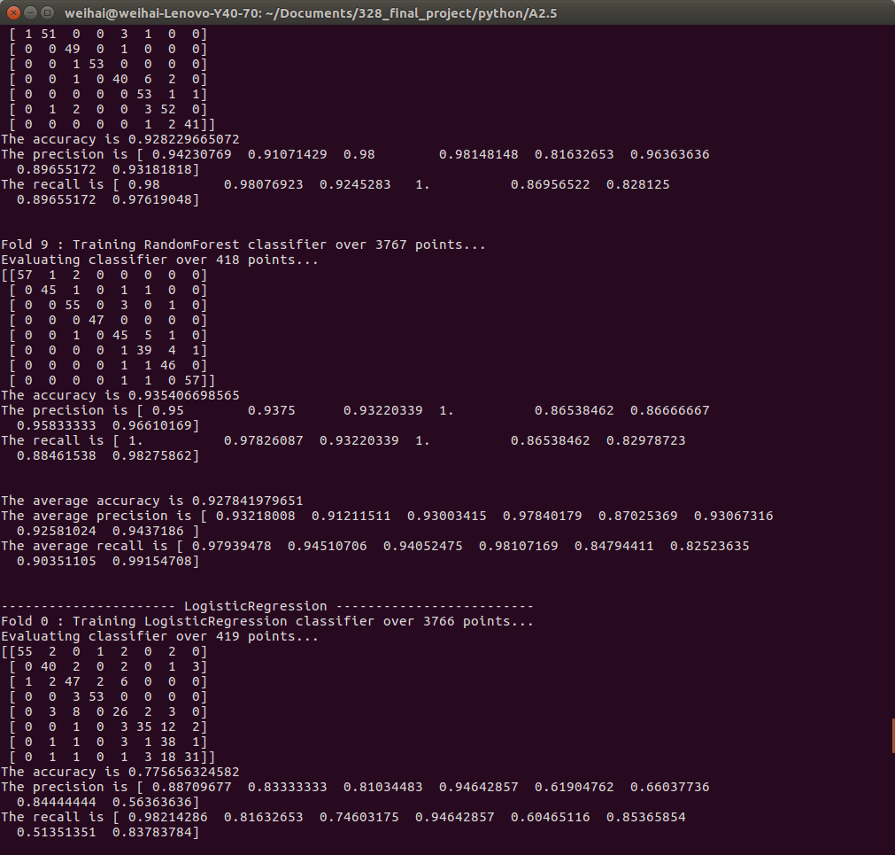

In practice, our classifier seems to have confused squatting and sitting down since the first part of squatting is exactly the same as sitting down. Most of the activities in the beginning share similar characteristic, like squatting and sitting down, dropping phone and falling, squatting and jumping. We tried expand the window size and step size of the sample to increase distinct difference between activities and it does work reasonably well but still not so accurate when classify squatting and everything else. Plus we might run in overfitting of our data.

What The App Looks Lik

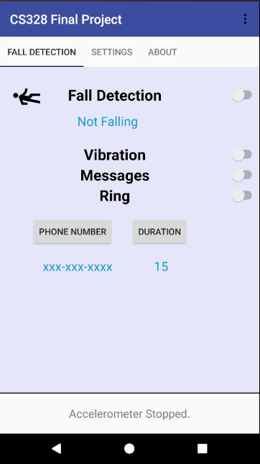 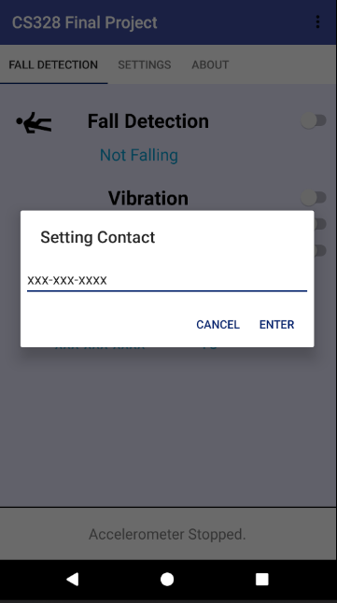 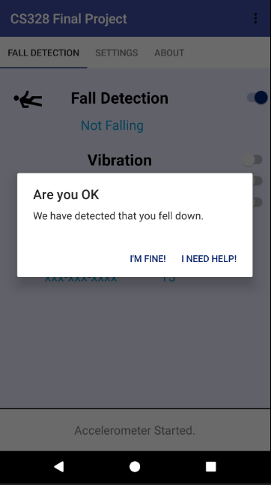 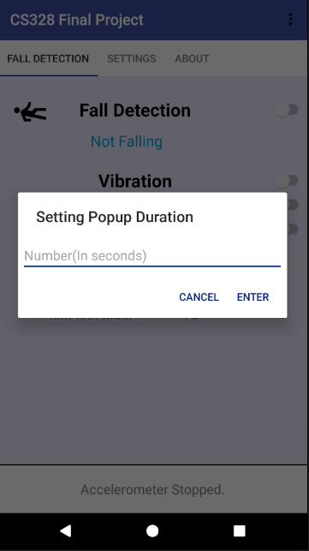

Reuslt:

Our app does not work very well due to when classify squatting and sitting down. But those two activities are not really our concerns. To avoid misclassify other activities as falling, we have set our app to report falling only if we have detect 3 consecutive falling in a row. We did not actually try our app in real life due to the nature of falling. But we suspect we have a lot to improve.

Future Possible Improvements

1. Train even more activities
2. Might be able to try it on wristband
3. More features like Tilt Angle for better accuracy
4. WakeLock and disable KeyGuard for locked phones
5. Find a better way to make the classifier works well in practice
6. Make our app work independent to phone’s rotation
7. Maybe add more fall activities like fall on objects.